1.

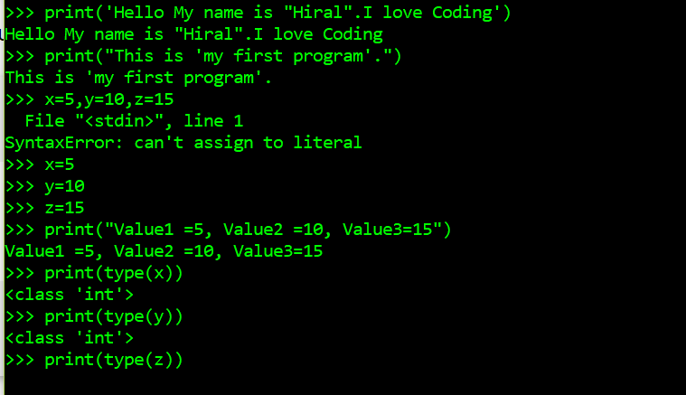

2.

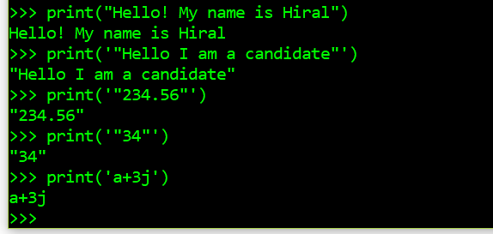

3.

>>> x=10+20\*(45+67.0)

>>> print(x)

2250.0

>>> print(type(x))

<class 'float'>

>>> x=(3>89) or (34>32)

>>> print(x)

True

>>> x=(True or True) and (not False and True)

>>> print(x)

True

>>> x=(True and False) or False

>>> print(x)

False

>>> x=not True and False

>>> print(x)

False

4.

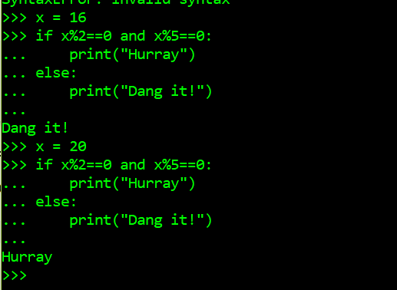

5.

